MULTI-YEAR SALES VS TARGET DASHBOARD
STEP-BY-STEP USER GUIDE



Data Drifters
Thato Msina
Jereshan Sinan
Fikile Noyila
Kaylene Martins
Lesedi Mphachake

27/02/2026

Refreshing the Data in Power BI
Follow the numbered steps below (refer to Screenshot 1):
- Step 1: Open the Power BI (.pbix) file.
- Step 2: On the Home ribbon, locate and click the 'Refresh' button.
- Step 3: Wait for the refresh process to complete.
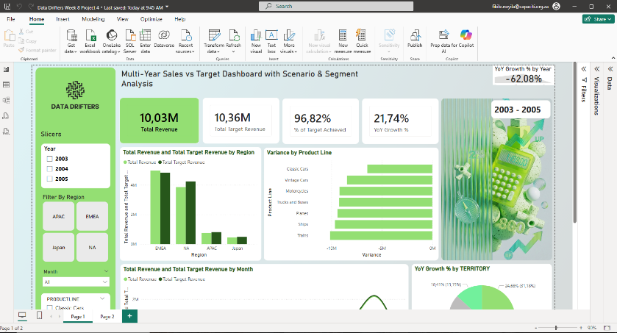
- Step 4: Confirm that KPI cards (Total Revenue, % Target Achieved) update automatically.
Screenshot 1: Main Power BI dashboard interface showing the Home ribbon and KPI cards.
Updating the Targets Table
Follow the numbered steps below (refer to Screenshot 2):
- Step 1: Identify the original Sales_Targets source file (Excel or database).
- Step 2: Open the file and update the target revenue values.
- Step 3: Save and close the source file.
- Step 4: Return to Power BI and click 'Refresh' to load updated targets.
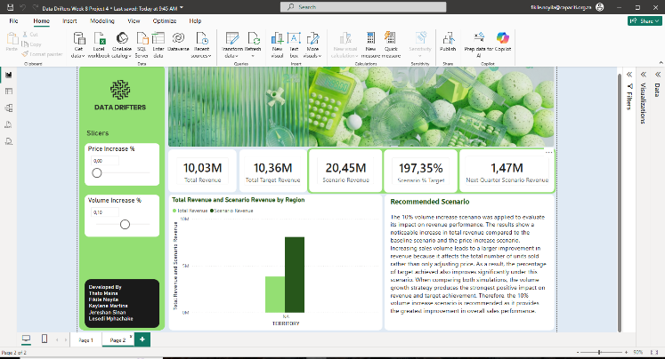
- Step 5: Verify that 'Total Target Revenue' and '% of Target Achieved' reflect the new values.

Screenshot 2: Scenario view and KPI cards after refreshing updated targets.

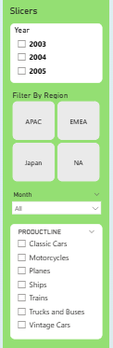
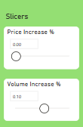
Using Slicers to Answer Common Questions
Use the slicers on the left panel to dynamically filter results (see screenshots above).
- Question 1: What was performance in a specific year?
• Select a year (2003, 2004, 2005) in the Year slicer.
• Review KPI cards and charts for updated results.
- Question 2: How did a region perform vs target?
• Click APAC, EMEA, Japan, or NA in the Region filter.
• Analyse the Revenue vs Target bar chart.
- Question 3: What is the impact of price or volume increases?
• Adjust the 'Price Increase %' or 'Volume Increase %' sliders.
• Observe changes in Scenario Revenue and Scenario % Target KPI cards.
Note: Multiple slicers can be applied simultaneously (Year + Region + Scenario) to perform deeper managerial analysis.

